**DAILY ONLINE ACTIVITIES SUMMARY**

|  |  |  |  |  |  |  |  |  |
| --- | --- | --- | --- | --- | --- | --- | --- | --- |
| **Date:** | **27-05-2020** | | | | | **Name:** | **Huda Sultana** | |
| **Sem & Sec** | **8 A** | | | | | **USN:** | **4AL16CS039** | |
| **Online Test Summary** | | | | | | | | |
| **Subject** | | **IOT** | | | | | | |
| **Max. Marks** | | **30** | | **Score** | | | **28** | |
| **Certification Course Summary** | | | | | | | | |
| **Course** | **Introduction to Amazon Elastic Compute Cloud(EC2)** | | | | | | | |
| **Certificate Provider** | | | **AWS** | | **Duration** | | | **10 mins** |
| **Coding Challenges** | | | | | | | | |
| **Problem Statement:**   1. **Write a C Program to sort an array of integers in ascending order and display the sorted array and Number of passes performed for sorting**. | | | | | | | | |
| **Status: Solved** | | | | | | | | |
| **Uploaded the report in Github** | | | | | **Yes** | | | |
| **If yes Repository name** | | | | | **Hudasulltana/online_coding** | | | |
| **Uploaded the report in slack** | | | | | **Yes** | | | |

Online Test Details: (Attach the snapshot and briefly write the report for the same)

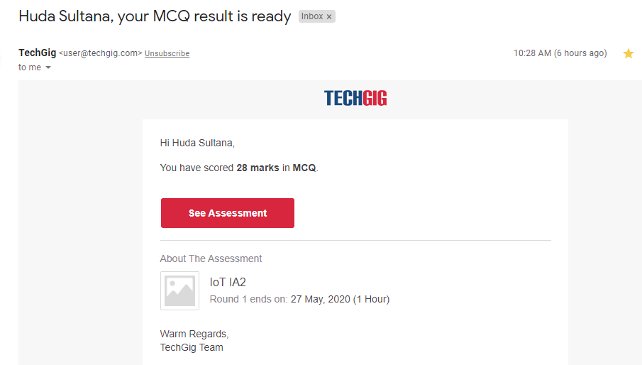

Certification Course Details: (Attach the snapshot and briefly write the report for the same)



Coding Challenges Details: (Attach the snapshot and briefly write the report for the same)

**PROGRAM 1 .**

**// Write a C Program to sort an array of integers in ascending order and display the sorted //array and Number of passes performed for sorting**.

**#include <stdio.h>**

**void swap(int *xp, int *yp)**

**{**

**int temp = *xp;**

**\*xp = *yp;**

**\*yp = temp;**

**}**

**int bubbleSort(int arr[], int n)**

**{**

**int i, j,count=0;**

**int swapped;**

**for (i = 0; i < n-1; i++)**

**{**

**swapped = 0;**

**for (j = 0; j < n-i-1; j++)**

**{**

**if (arr[j] > arr[j+1])**

**{**

**swap(&arr[j], &arr[j+1]);**

**swapped = 1;**

**count++;**

**}**

**}**

**if (swapped == 0)**

**break;**

**}**

**return count;**

**}**

**void printArray(int arr[], int size)**

**{**

**int i;**

**for (i=0; i < size; i++)**

**printf("%d ", arr[i]);**

**printf("\n");**

**}**

**int main()**

**{**

**int arr[50],num;**

**printf("enter the number of elements");**

**scanf("%d",&num);**

**printf("enter the elements");**

**for(int i=0;i<num;i++){**

**scanf("%d",&arr[i]);**

**}**

**int c=bubbleSort(arr, num);**

**printf("Sorted array: \n");**

**printArray(arr, num);**

**printf("Number of passes:%d\n",c);**

**return 0;**

**}**